**PROGRAM 5. AIRLINE FLIGHT DATABASE**

Consider the following database that keeps track of airline flight information:

FLIGHTS (flno: integer, from: string, to: string, distance: integer, departs: time, arrives: time, price: integer)

AIRCRAFT (aid: integer, aname: string, cruisingrange: integer)

CERTIFIED (eid: integer, aid: integer)

EMPLOYEE (eid: integer, ename: string, salary: integer)

Note that the Employees relation describes pilots and other kinds of employees as well; Every pilot is certified for some aircraft, and only pilots are certified to fly.

**Write each of the following queries in SQL**.

CREATE TABLE FLIGHTS(FLNO INTEGER PRIMARY KEY,FROMM VARCHAR(15) NOT NULL,TOO VARCHAR(15) NOT NULL,DISTANCE INTEGER,DEPARTS TIME,ARRIVES TIME,PRICE INTEGER);

INSERT INTO flights VALUES(101,'Bangalore','Delhi',2500,'07:15:31','17:15:31',5000);

INSERT INTO flights VALUES(102,'Bangalore','Lucknow',3000,'07:15:31','11:15:31',6000);

INSERT INTO flights VALUES(103,'Lucknow','Delhi',500,'12:15:31','17:15:31',3000);

INSERT INTO flights VALUES(107,'Bangalore','France',8000,'07:15:31','22:15:31',60000);

INSERT INTO flights VALUES(104,'Bangalore','France',8500,'07:15:31','23:15:31',75000);

INSERT INTO flights VALUES(105,'Kolkata','Delhi',3400,'07:15:31','09:15:31',7000);

SELECT *FROM FLIGHTS;

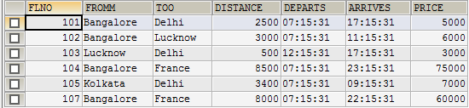

CREATE TABLE AIRCRAFT(AID INTEGER PRIMARY KEY,ANAME VARCHAR(10),CRUISINGRANGE INTEGER);

INSERT INTO aircraft VALUES(101,'indigo',3000);

INSERT INTO aircraft VALUES(102,'Boeing',900);

INSERT INTO aircraft VALUES(103,'hal',800);

INSERT INTO aircraft VALUES(104,'Dreamliner',10000);

INSERT INTO aircraft VALUES(105,'Boeing',3500);

INSERT INTO aircraft VALUES(106,'tejas',1500);

INSERT INTO aircraft VALUES(107,'Dream', 120000);

SELECT *FROM AIRCRAFT;

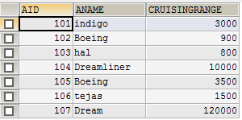

CREATE TABLE EMPLOYEES(EID INTEGER PRIMARY KEY,ENAME VARCHAR(15),SALARY_NUMBER INTEGER);

INSERT INTO employees VALUES(701,'A',50000);

INSERT INTO employees VALUES(702,'B',100000);

INSERT INTO employees VALUES(703,'C',150000);

INSERT INTO employees VALUES(704,'D',90000);

INSERT INTO employees VALUES(705,'E',40000);

INSERT INTO employees VALUES(706,'F',60000);

INSERT INTO employees VALUES(707,'G',90000);

SELECT *FROM EMPLOYEES;

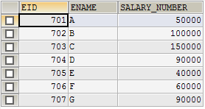

CREATE TABLE CERTIFIED(EID INTEGER NOT NULL,AID INTEGER NOT NULL,PRIMARY KEY (EID, AID),FOREIGN KEY (EID) REFERENCES EMPLOYEES (EID),FOREIGN KEY (AID) REFERENCES AIRCRAFT (AID));

INSERT INTO certified VALUES(701,101);

INSERT INTO certified VALUES(701,102);

INSERT INTO certified VALUES(701,106);

INSERT INTO certified VALUES(701,105);

INSERT INTO certified VALUES(702,104);

INSERT INTO certified VALUES(703,104);

INSERT INTO certified VALUES(704,104);

INSERT INTO certified VALUES(702,107);

INSERT INTO certified VALUES(703,107);

INSERT INTO certified VALUES(704,107);

INSERT INTO certified VALUES(702,101);

INSERT INTO certified VALUES(703,105);

INSERT INTO certified VALUES(704,105);

INSERT INTO certified VALUES(705,103);

SELECT *FROM certified;

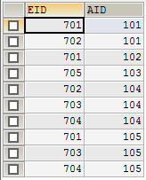

**i. Find the names of aircraft such that all pilots certified to operate them have salaries more than Rs.80,000.**

SELECT DISTINCT a.aname FROM aircraft a,certified c,employees e WHERE a.aid=c.aid AND c.eid=e.eid AND NOT EXISTS(SELECT *FROM employees e1 WHERE e1.EID=e.EID AND 'e1.salary<80000');

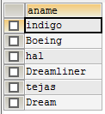

**ii. For each pilot who is certified for more than three aircrafts, find the eid and the maximum cruising range of the aircraft for which she or he is certified.**

SELECT c.eid,MAX(cruisingrange)FROM certified c,aircraft a WHERE c.aid=a.aid GROUP BY c.eid HAVING COUNT(*)>3;



**iii. Find the names of pilots whose salary is less than the price of the cheapest route from Bengaluru to**

**Frankfurt.**

SELECT DISTINCT E.ename FROM Employees E WHERE E.SALARY_NUMBER<(SELECT MIN(F.price)FROM Flights F WHERE F.fromm='Bangalore' AND F.too='France');



**iv. For all aircraft with cruising range over 1000 Kms, find the name of the aircraft and the average salary of all pilots certified for this aircraft.**

SELECT a.aname,AVG(e.SALARY_NUMBER)FROM aircraft a,certified c,employees e WHERE a.aid=c.aid AND c.eid=e.eid AND a.cruisingrange>1000 GROUP BY a.aid,a.aname;

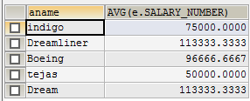

**v. Find the names of pilots certified for some Boeing aircraft.**

SELECT DISTINCT E.ename FROM Employees E, Certified C, Aircraft A WHERE E.eid = C.eid AND C.aid = A.aid AND A.aname LIKE 'Boeing%';

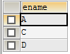

**vi. Find the aids of all aircraft that can be used on routes from Bengaluru to New Delhi.**

SELECT A.aid FROM Aircraft A WHERE A.cruisingrange>(SELECT MIN(F.distance)FROM Flights F WHERE F.fromm='Bangalore' AND F.too='France');



**vii. A customer wants to travel from Madison to New York with no more than two changes of flight. List the choice of departure times from Madison if the customer wants to arrive in New York by 6 p.m.**

SELECT F.departs FROM Flights F WHERE F.flno IN((SELECT F0.flno FROM Flights F0 WHERE F0.fromm ='Bangalore' AND F0.too ='Delhi'AND EXTRACT(HOUR FROM F0.arrives)<18) UNION (SELECT F0.flno FROM Flights F0, Flights F1 WHERE F0.fromm='Bangalore' AND F0.too <> 'Delhi' AND F0.too=F1.fromm AND F1.too='Delhi' AND F1.departs>F0.arrives AND EXTRACT(HOUR FROM F1.arrives)<18)UNION (SELECT F0.flno FROM Flights F0 WHERE F0.fromm ='Bangalore' AND F0.too = ‘Delhi’));

**DEPARTS**

**-------------------------------------------------------------------------**

**05/05/13 07:15:31.000000**

**05/05/13 07:15:31.000000**

**viii. Print the name and salary of every non-pilot whose salary is more than the average salary for pilots.**

SELECT E.ename, E.SALARY_NUMBER FROM Employees E WHERE E.eid NOT IN(SELECT DISTINCT C.eid FROM Certified C)AND E.SALARY_NUMBER>(SELECT AVG (E1.SALARY_NUMBER)FROM Employees E1 WHERE E1.eid IN(SELECT DISTINCT C1.eid FROM Certified C1 ) );

